**PRACTICAL NO 8**

**AIM :** Implementation of Openstack with user and private network creation

**SOLUTION:**

**Step 1 :** Update and Upgarde your ubuntu system

**Step 2:** Install Microstack beta

Command : *sudo snap install microstack --beta*



**Step 3:** Check the installed status and version of the MicroStack snap package.

Command : *snap list microstack*



**Step 4:** initialize MicroStack

Command : *sudo microstack init --auto --control*

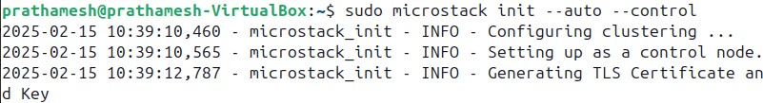

**Step 5:** Check the installed version of OpenStack

Command : *microstack.openstack --version*



**Step 6:** Retrieve the Keystone password for the OpenStack deployment managed by MicroStack.

Command : *sudo snap get microstack config.credentials.keystone-password*



**Step 7:**Note down the IP address of your linux system

Command :  *ip a*

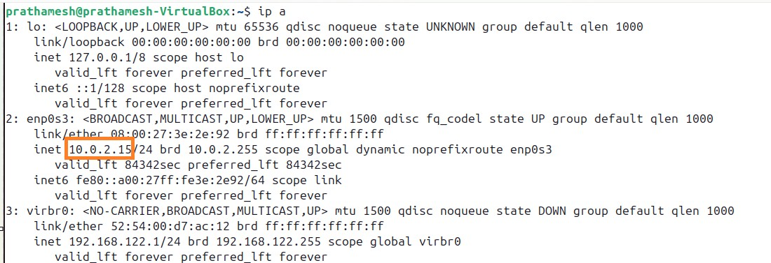

**Step 8:**Now paste inet : 10.0.2.15 in browser it will open the following login page of Openstack



**Step 9:**Fill the usernameas ‘admin’ and password which is provided in step6

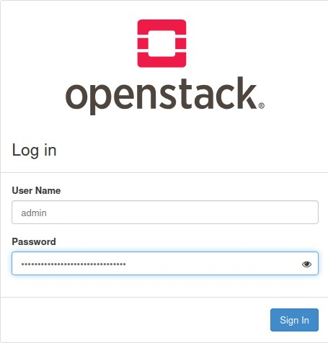

**Step 10:**Congratulation you logged in OpenStack

